Investigation of the properties of structural materials using the tensile test method
  - Instructions for a laboratory exercise in materials engineering

1. Objective of the exercise
Celem ćwiczenia jest:
- zapoznanie się z przebiegiem statycznej próby rozciągania,
- wyznaczenie podstawowych właściwości mechanicznych materiału,
- analiza wykresu naprężenie–odkształcenie,
- ocena zachowania materiału podczas obciążania.
Podczas zajęć studenci wykonają próbę rozciągania dla wybranego materiału konstrukcyjnego oraz opracują wyniki pomiarów.

The aim of the exercise is to:
- become familiar with the course of a static tensile test,
- determine the basic mechanical properties of a material,
- analyze the stress–strain curve,
- assess the behavior of the material under loading.
During the class, students will perform a tensile test on a selected structural material and process the measurement results.

2. Equipment of the test station
The following equipment is required to perform the exercise:
Table 1. Required test station equipment
Equipment element | Application
Universal testing machine | execution of the tensile test
Vernier caliper | measurement of specimen dimensions
Computer with software | data acquisition
Steel and aluminum specimens | test material

3. Safety rules
Before starting the exercise, you must:
- wear safety goggles,
- check the condition of the test station,
- ensure that the specimen is properly mounted,
- maintain a safe distance from the machine during testing.
It is forbidden to touch moving parts of the device during operation.

4. Procedure of the exercise

Stage 1 – Specimen measurement
Measure the initial gauge length and diameter of the specimen.
Table 2. Specimen properties
Parameter | Symbol | Value
Initial length | L0 | 50 mm
Specimen diameter | d | 12 mm
Cross-sectional area | S0 | 113 mm²
All measurements should be taken with an accuracy of 0.1 mm.

Stage 2 – Tensile test execution
- Mount the specimen in the machine grips.
- Set the appropriate displacement speed.
- Start the measurement.
- Observe the behavior of the specimen during loading.
- Record the results.

Stage 3 – Data processing
Based on the recorded data, determine:
- yield strength,
- ultimate tensile strength,
- relative elongation,
- Young’s modulus.

5. Test results
Table 1 Obtained test results
Material | Material |  | Material
 | Re [MPa] | Rm [MPa] | A [%] | Z [%]
Steel S235 | 235 | 410 | 26 | 35
Aluminium PA6 | 235 | 290 | 14 | 20
„To invent, you need a good imagination and a pile of junk.” — Thomas Edison

6. Stress–strain curve
The stress–strain curve (tensile curve, Figure 1) is a graphical representation of the relationship between stress and strain, obtained during strength testing of materials (e.g., metals, plastics). It reflects the behavior and resistance of a material under load—from its initial state up to fracture.
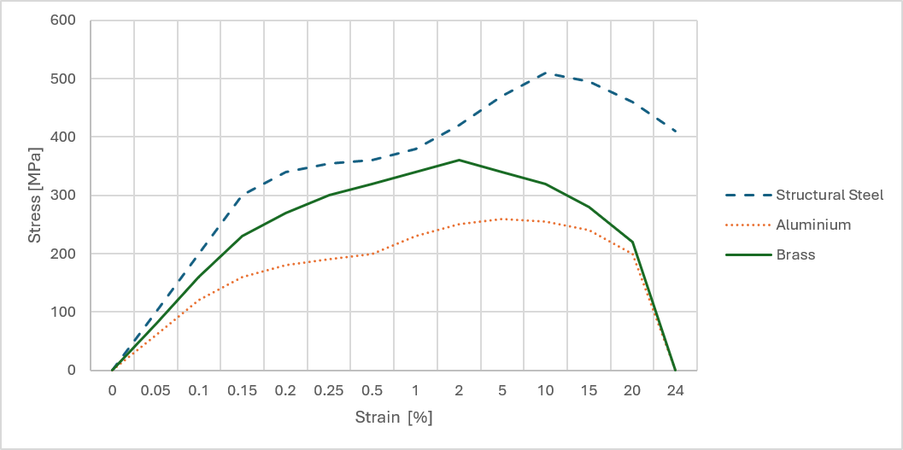
Figure 1 Example tensile curves for three selected materials.
The image shows a professional testing station, whose main element is a vertical, dual-column universal testing machine (model 6.1000). This device, together with its control system and hydraulic power unit, is used for static destructive tests, primarily tensile testing. The station features a rigid frame construction, ensuring high stiffness necessary for precise application of large mechanical loads.
In the central part of the machine there are powerful grips (jaws) designed to securely hold the ends of the tested specimen. Above them is a movable crosshead, which travels vertically along the columns using lead screws protected by yellow covers. This mechanism enables controlled and smooth stretching of the material until fracture.
The presented station allows precise force application and simultaneous recording of specimen geometry changes using an integrated measurement system. This enables accurate determination of basic mechanical properties of tested materials, such as yield strength and ultimate tensile strength.
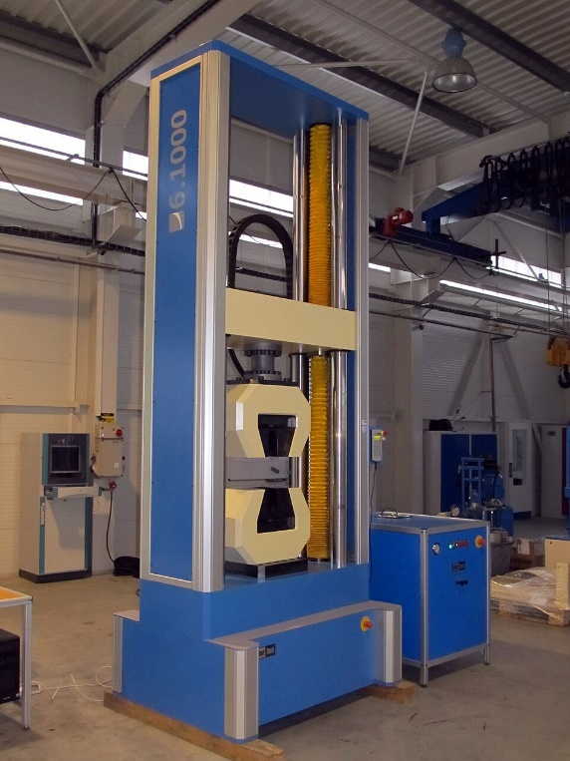
Figure 2 Example 1000 kN universal testing machine (LaborTech).
Figure 3 shows an example of a steel cylindrical specimen after a static tensile test, where the fracture location is clearly visible, allowing evaluation of the fracture type. Near the fracture, a local reduction in diameter (necking) can be observed. The geometry of indentations along the specimen indicates significant plastic deformation prior to failure. Such plastic deformation, combined with a matte and rough fracture surface, is a classic example of ductile fracture. It is the opposite of brittle fracture, which occurs suddenly, perpendicular to the loading axis, and without visible plastic deformation. The millimeter paper background on which the fractured specimen is placed additionally allows visual estimation of the scale and total plastic elongation of the gauge section.
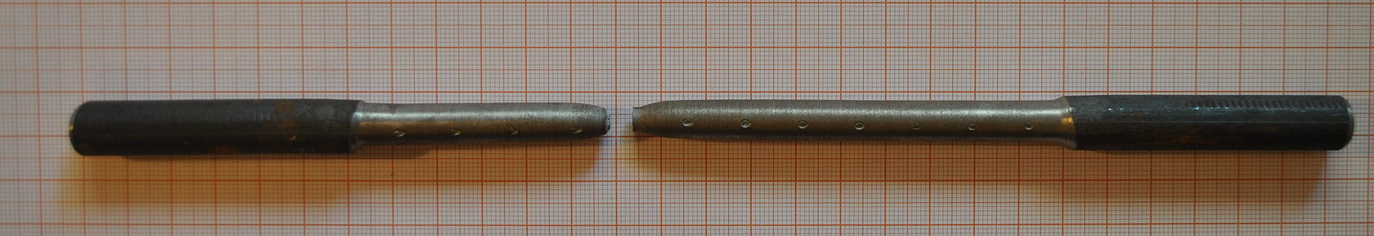
Figure 3 Specimen after static tensile test.

7. Supporting materials:
- Static tensile testing of metals
- ISO 6892-1:2009(E)

